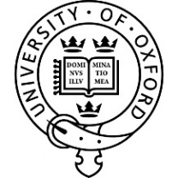

Ancient Medicine Seminar

An interdisciplinary research seminar, intended to bring together those inside the University
and elsewhere who have an interest in disease and medicine in the ancient world

These seminars will be held remotely by Zoom until further notice
The log-on for attending these seminars is
https://us02web.zoom.us/j/83752251729

HILARY TERM 2021
Alternative Wednesdays at 17.30-19.00 GMT

20 January Dr Tomáš Alušík (Charles University, Prague and Oxford Centre for History of Science, Medicine and Technology)
The Asklepieion-Pythion of Paros: restudy of the old evidence

3 February Dr Laurence Totelin (Cardiff University)
Retail Therapy: Selling drugs, buying health in the Roman Empire

17 February Dr Vincenzo Damiani (Universities of Würzburg and Ulm)
How shall I live? Lifestyle definition between medicine, philosophy and religion in the Early Roman Imperial Period

3 March Professor Robert Arnott (Green Templeton College)
Mycenaean healing cult in the Hittite Capital of Hattuša-Boğazköi

Convener
Professor Robert Arnott
Green Templeton College

For further details and to be added to the mailing list, please contact robert.arnott@gtc.ox.ac.uk

ALL ARE WELCOME TO ATTEND

