Medieval Archaeology Seminar
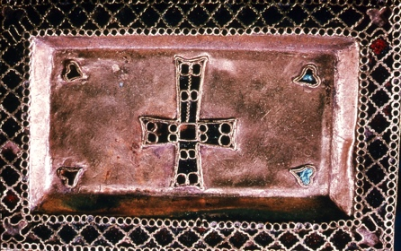
Mondays, 3.00

Teams link:
https://teams.microsoft.com/l/channel/19%3a804090b0492c409894015b7a6c6bba7f%40thread.tacv2/Medieval%2520Archaeology%2520Seminar?groupId=550fb0dc-672f-428e-81c4-e3d5e5f63b47&tenantId=cc95de1b-97f5-4f93-b4ba-fe68b852cf91

Week 2 – No seminar this week

Week 4 (8 Feb) Medieval Migrants of the North Sea World. A bioarchaeological analysis of human mobility
Letty ten Harkel and Eleanor Farber (Oxford)

Week 6 (22 Feb) Gjellestad. A Viking Period ship grave and its surroundings.
Christian Lochsen Rodsrud (Oslo)

Week 8 (8 March) Ephemeral architecture, seasonal activities, permanent settlement and urban timelines in Viking-Age Ribe
Sarah Croix (Aarhus)

Convenors: J. Kershaw/ H Hamerow

