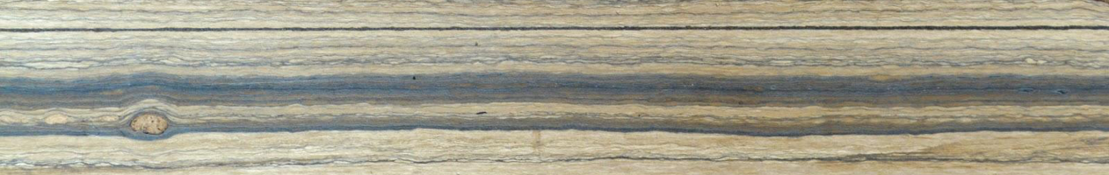

Research Laboratory for Archaeology and the History of Art

School of Archaeology

**Climate & Chronology Seminar Series**

**Lecture Theatre, 1 South Parks Road**

**Tuesdays 12:00-13:00**

The Climate and Chronology group brings together like-minded individuals in an informal setting. We wish to produce stimulating discussions, disseminate high quality data, and learn more about current research. We welcome anyone who is interested in climate and/or chronology.

Please sign up to our mailing list for seminar announcements

(send an email to **climchron-subscribe@maillist.ox.ac.uk**)

Any queries contact Rachel Wood: rachel.wood@arch.ox.ac.uk

**Hilary 2025 Term Card**

**Week 3 – 4th feb**

**Francesco Muschitiello** | Associate Professor | University of Cambridge

*TBC*

**Week 6 –25th feb**

**Mark stevenson** | Postdoctoral Researcher| University of Oxford

*Mid-Holocene sea-ice dynamics and climate in the northeastern Weddell Sea inferred from an Antarctic snow petrel stomach oil deposit*

**Week 7 – 4th mar**

**Gerard Barrett** | Radiocarbon Accelerator Mass Spectrometry Unit Manager | Queen’s University, Belfast

*A Burning Issue – Ramped Pyrolysis Radiocarbon Dating of Very Tricky Materials*

**Week 8 – 11th mar**

**NEIL roberts** | Honorary Research Associate | University of Oxford

*Climate as a driver of Neolithic human-environment dynamics on the Konya plain, south central Anatolia*